Department of Computer Technology

Vision of the Department
To be a well-known centre for pursuing computer education through innovative pedagogy, value-based education and industry collaboration.

Mission of the Department
To establish learning ambience for ushering in computer engineering professionals in core and multidisciplinary area by developing Problem- solving skills through emerging technologies.

Session 2025-2026
Mission: Means to achieve Vision
Vision: Dream of where you want.

Program Educational Objectives of the program (PEO): (broad statements that describe the professional and career accomplishments)
PEO1 | Preparation | P: Preparation | Pep-CL abbreviation  pronounce as Pep-si-lL easy to recall
PEO2 | Core Competence | E: Environment (Learning Environment)
PEO3 | Breadth | P: Professionalism
PEO4 | Professionalism | C: Core Competence
PEO5 | Learning Environment | L: Breadth (Learning in diverse areas)

Program Outcomes (PO): (statements that describe what a student should be able to do and know by the end of a program)

Keywords of POs:
Engineering knowledge, Problem analysis, Design/development of solutions, Conduct Investigations of Complex Problems, Engineering Tool Usage, The Engineer and The World, Ethics, Individual and Collaborative Team work, Communication, Project Management and Finance, Life-Long Learning
PSO Keywords: Cutting edge technologies, Research
“I am an engineer, and I know how to apply engineering knowledge to investigate, analyse and design solutions to complex problems using tools for entire world following all ethics in a collaborative way with proper management skills throughout my life.” to contribute to the development of cutting-edge technologies and Research.

Integrity: I will adhere to the Laboratory Code of Conduct and ethics in its entirety.

Name and Signature of Student and Date
(Signature and Date in Handwritten)

Department of Computer Technology

Vision of the Department
To be a well-known centre for pursuing computer education through innovative pedagogy, value-based education and industry collaboration.

Mission of the Department
To establish learning ambience for ushering in computer engineering professionals in core and multidisciplinary area by developing Problem- solving skills through emerging technologies.

Session | 2025-26 (ODD) | Course Name | Operating System Lab
Semester | 5 | Course Code | 23IOT1504
Roll No | 01 | Name of Student | Anushka Yede

Practical Number | Practical no 7
Course Outcome | - Understand Computer System Configuration and Simulate system resources efficiently using Linux Commands (CO1)  - Analyse operating system functionalities utilizing system calls, thread programming and process scheduling algorithms (CO2)  - Apply Synchronization primitives to implement a Deadlock-free solution(CO3)  - Simulate Disk scheduling, Memory allocation, File allocation, page replacement algorithms (CO4)
Aim | Implement aprogram to stimulate disk scheduling algorithm  - FCFS  - SSTF
Problem Definition | This program simulates FCFS and SSTF disk scheduling algorithms.  FCFS serves requests in the order they arrive.  SSTF selects the nearest request to the current head position. It compares both by calculating total and average seek time.
Theory  (100 words) | In disk scheduling, the disk arm moves between tracks to read or write data. The seek time is the time taken for this movement.  - FCFS (First Come First Serve): Processes disk requests in the order they arrive. It’s simple but may cause long movements between far requests.  - SSTF (Shortest Seek Time First): Selects the request nearest to the current head position, minimizing immediate seek time. However, it may cause starvation for distant requests.  Comparing both helps understand the trade-off between fairness (FCFS) and efficiency (SSTF).
Procedure and Execution | Start the program and input the number of disk requests.  Enter the sequence of track numbers and the initial head position.

(100 Words) | For FCFS, process requests in the same order and calculate the seek distance between consecutive requests.  For SSTF, from the current head position, choose the nearest track and move there next.  Continue until all requests are served. Calculate total and average seek time for both. Display the results for comparison.  Stop the program.
Code:
#include <stdio.h> #include <stdlib.h> #include <math.h>
void FCFS(int requests[], int n, int head) { int total = 0;
printf("\nFCFS Disk Scheduling:\n"); for (int i = 0; i < n; i++) {
printf("Move from %d to %d = %d\n", head, requests[i], abs(head - requests[i]));
total += abs(head - requests[i]); head = requests[i];
}
printf("Total Seek Time = %d\n", total); printf("Average Seek Time = %.2f\n", (float)total / n);
}
void SSTF(int requests[], int n, int head) { int total = 0, completed = 0;
int visited[100] = {0}; printf("\nSSTF Disk Scheduling:\n"); while (completed < n) {
int min = 9999, index = -1; for (int i = 0; i < n; i++) {
if (!visited[i] && abs(head - requests[i]) < min) { min = abs(head - requests[i]);
index = i;
}
}
visited[index] = 1;
printf("Move from %d to %d = %d\n", head, requests[index], min);
total += min;
head = requests[index]; completed++;
}

printf("Total Seek Time = %d\n", total);
printf("Average Seek Time = %.2f\n", (float)total / n);
}
int main() { int n, head;
printf("Enter number of requests: "); scanf("%d", &n);
int requests[n];
printf("Enter the request sequence: "); for (int i = 0; i < n; i++)
scanf("%d", &requests[i]);
printf("Enter initial head position: "); scanf("%d", &head);
FCFS(requests, n, head); SSTF(requests, n, head);
return 0;
}
Output:
FCFS AND SSTF

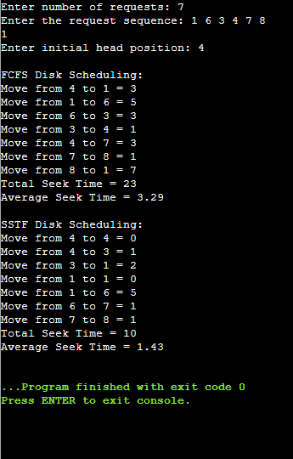

Department of Computer Technology

Vision of the Department
To be a well-known centre for pursuing computer education through innovative pedagogy, value-based education and industry collaboration.

Mission of the Department
To establish learning ambience for ushering in computer engineering professionals in core and multidisciplinary area by developing Problem- solving skills through emerging technologies.

Output Analysis | In the example, FCFS leads to large head movements since it follows arrival order, causing more total seek time (460).  SSTF, however, picks the nearest request each time, reducing total seek time to 172. Thus, SSTF is faster but not always fair to distant requests.
Link of student Github profile where lab assignment has been uploaded
Conclusion | The simulation shows that SSTF performs better than FCFS in terms of seek time and efficiency. FCFS is simpler and fair but can cause longer waiting times. SSTF improves response time by reducing unnecessary head movement, making it more suitable for systems that prioritize performance..
Plag Report (Similarity index < 12%) | 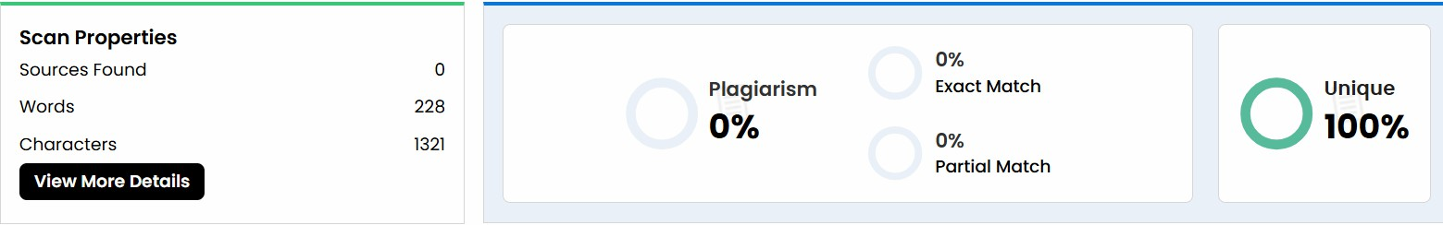
Date | 29/10/25

